

An API refers to a set of functions built into an application, which can be used by other applications (or by itself), to interact with application. An API is a great way to expose an application’s functionality to external applications safely and securely, since all functionality that these external applications can do is limited with what functionality is exposed in the API.

**API-Centric Web Application**

An API-Centric Web Application is a web application that basically executes most, if not, all its functionality through API calls (requests). It is a software system for distributing the data in json format to different kinds of applications.

**Advantage**

It’s common knowledge that people today don’t just use applications via a browser, but through other gadgets, like mobile phones and tablets. Thus, creating an API-Centric Web application would inevitably lead to more usage of our application.

Furthermore, the advantage of creating an API-Centric application is that it helps you build functionality that can be used by any device, be it a browser, a mobile phone, a tablet or even a desktop app. All you need to do is to create the API in such a way that all these devices can communicate with it. By creating an application in this manner, we are able to easily take advantage of the different mediums or platforms used by different people.

OVERVIEW:

Our API is REST-based.

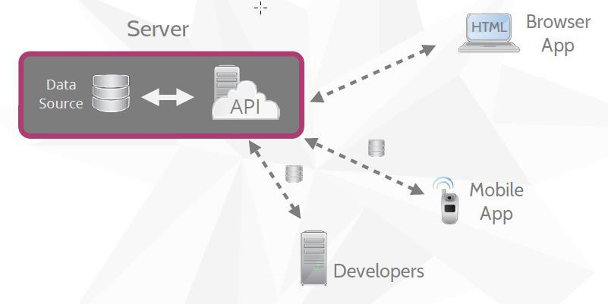

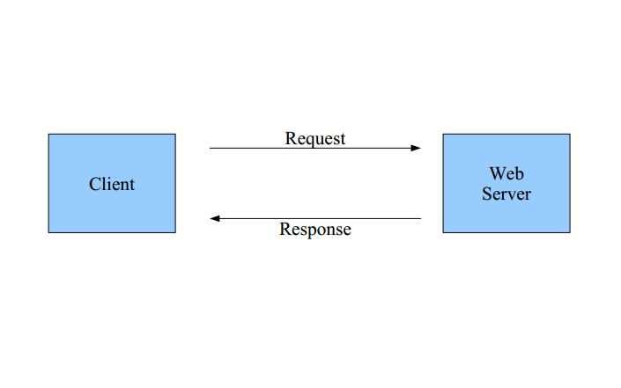

REST is an architecture all about the Client-Server communication.

**REQUESTS:**

The request to a resource is identified by **URL (URL = Unified Resource Identifier)**. Every resource is URL addressable

**CRUD Operations Mapped to HTTP Methods in RESTful Web Services**

|  |  |
| --- | --- |
| **OPERATION** | **HTTP METHOD** |
| CREATE | POST |
| READ | GET |
| UPDATE | PUT or POST |
| DELETE | DELETE |

These request verbs are:

**GET**:*fetch*an existing resource. The URL contains all the necessary information the server needs tolocate and return the resource.

**POST**:*create*a new resource. POST requests usually carries a payload that specifies the data for thenew resource. All the POST request data should be encoded as standard application/x-www-form-urlencoded

**PUT**:*update*an existing resource. The payload may contain the updated data for the resource.

**DELETE**:*delete*an existing resource.